▶Tips◀
- Light baking quality is better in Built-In than URP.
- You need to check this: Project Settings -> Player -> Other Settings - > Rendering - > Color Space = Linear.
- If you see some ugly baked light or insane bake time, adjust Lightmap Resolution or Max Lightmap Size in Lighting Setting.
- Make sure Color Space is 'Linear'. You can check it in Project Setting -> Player->Other Setting -> Rendering.
- If your Project is URP, Please Extract 'Cyberpunk Interior_URP Install-Package'.
- If your Project is Built-In, Please Extract 'Cyberpunk Interior _Built-In Install-Package'.
- You cannot use too many Video signboards in the scene (It depends on the computer performance). If you see some reading Video errors in play mode, reopen your project and try to play again. In my case, when it stopped in play mode because of reading video errors, I just ignore it and press pause button to play it.
- If you change the scale of building prefabs that has area lights to negative number, you need to change the area lights inside of the prefabs you changed to negative number as well.
- If you have any questions, feel free to join the Discord channel or send an email.
- Grid and Snap size is 2.286. 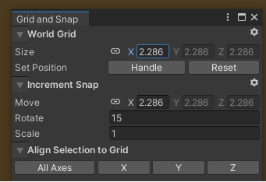

Discord channel: https://discord.com/invite/up56mKaHy8
Email Address: info.gypstudios@gmail.com

Thank you for purchasing :)

